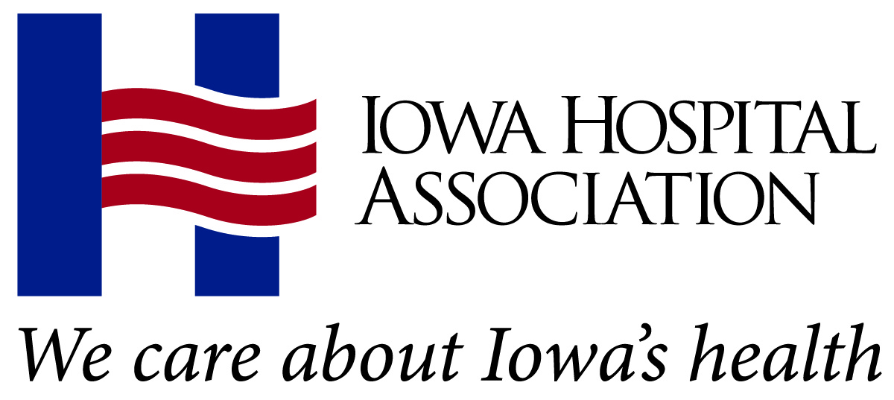
2022 Annual Meeting
Excellence in Leadership Award
Scoring Guide

Nominee:
Letter of nomination and supporting materials (40 points) |  | Points possible | Points awarded
Consider:  - Contributions to the advancement of the profession of hospital/health system administration through demonstrated effectiveness at the local, state or national level.  - Evident community contact and involvement as a leader in the broad spectrum of health care affairs (involvement in AHA activities, other national, state or local health care organizations and community organizations).  - Record of effectiveness in the management of his or her hospital/health system. |  | 40
Candidate’s ability to meet the intent of the award (30 points) |  | Points possible | Points awarded
IHA’s Excellence in Leadership Award recognizes an Iowa hospital or health system executive who has demonstrated notable achievement in the management of his or her hospital/health system and has had dynamic involvement in the broad area of health affairs.  Candidates also should show effectiveness at state/national efforts, management of their organizations and effectiveness in their communities. |  | 30
Candidate’s IHA participation and engagement (30 points) |  | Points possible | Points awarded
Consider:  - Attendance and engagement at IHA conferences and signature events (Annual Meeting, Summer Forum, Hospital Day on the Hill, Governance Forum).  - Attendance at IHA district meetings.  - Contributions to the IHA PAC.  - Service on IHA, IHERF and ServiShare boards, councils or committees. |  | 30
TOTAL  Scoring guide:  0-10 Very weak  11-20 Weak  21-30 Average  31-40 Strong  41-50 Very strong |  | 100 | 80
Reviewer comments:

Reviewer name: | Date:

