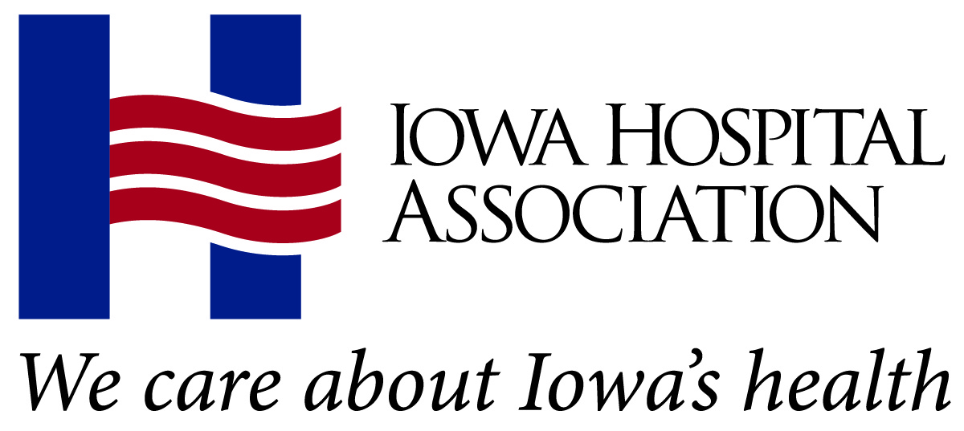
2022 Annual Meeting
Excellence in Governance Award
Scoring Guide

Nominee:
Letter of nomination and supporting materials (40 points) |  | Points possible | Points awarded
Consider:  - Focuses management attention on the health care needs of the communities served, the resources of the organization and the steps needed to successfully merge this information into a plan for success.  - Understands the strategic vision of the organization and the ambassadorial role, and combines the two in organizing and using resources to achieve goals.  - Works in concert with management and the medical staff to interface with key members of the public to influence their perceptions and actions taken for the organization. |  | 40
Candidate’s ability to meet the intent of the award (30 points) |  | Points possible | Points awarded
Candidates are strategic thinkers, diplomats, leaders, and effective and respected hospital trustees inside and outside the hospital. |  | 30
Candidate’s IHA participation and engagement (30 points) |  | Points possible | Points awarded
Consider:  - Attendance and engagement at IHA conferences and signature events (Annual Meeting, Summer Forum, Hospital Day on the Hill, Governance Forum).  - Contributions to the IHA PAC.  - Received individual or hospital board IHA trustee certification. |  | 30
TOTAL  Scoring guide:  0-10 Very weak  11-20 Weak  21-30 Average  31-40 Strong  41-50 Very strong |  | 100
Reviewer comments:

Reviewer name: | Date:

