Normal Hemodynamic and Blood Flow Parameters
Parameter | Abbreviation | Formula | Normal Range
Cardiac output | CO | Stroke volume (SV) x heart rate (HR) | 4-8 L/min
Cardiac index | CI | CO/BSA ÷ 1000 | 2.5-4.3 L/min/m²
Mean arterial pressure | MAP | 2(DBP) + SBP ÷ 3 | 70-105 mmHg
Right arterial pressure | RAP | Cm H₂O = mm HG x 1.34 | 2-8 mmHg
Pulmonary artery wedge pressure | PAOP |  | 8-12 mmHg
Pulmonary artery systolic | PAS |  | 15-35 mmHg
Pulmonary artery diastolic | PAD |  | 10-15 mmHg
Pulmonary vascular resistance | PVR | PAM-PAOP x 80 ÷ CO | 100-250 dynes/s/cm⁻⁵
Pulmonary vascular resistance index | PVRI | PAM-PAOP x 80÷ CI | 25-285 dynes/s/cm⁻⁵/m²
Pulmonary artery mean | PAM |  | 15-20 mmHg
Systemic vascular resistance | SVR | MAP-RAP x 80 ÷ CO | 800-1200 dynes/s/cm⁻⁵
Systemic vascular resistance index | SVRI | MAP-RAP x 80 ÷ CI | 1970-2390 dynes/s/cm⁻⁵/m²
Right ventricular stroke work index | RVSWI | (PAM-RAP)SVI x 0.0138 | 7-12 g/m/m²/beat
Left ventricular stroke work index | LVSWI | (MAP-PAOP)SVI x 0.0138 | 35-85 g/m/m²/beat
Oxygen delivery | DO₂ | CaO₂ x CO x 10 | 900-1100 mL/min
Oxygen delivery index | DO₂I | CaO₂ x CI x 10 | 360-600 mL/min/m²
Oxygen consumption | VO₂ | C(a-v)O₂ x CO x 10 | 200-250mL/min
Oxygen consumption index | VO₂I | C(a-v)O₂ x CI x 10 | 108-165 mL/min/m²
Stroke volume | SV | CO/HR x 1000 | 50-100 mL/beat
Stroke volume index | SVI | CI/HR x 1000 | 35-60 mL/beat/m²
Ejection fraction | EF |  | >60%
Right ventricular end-diastolic volume | RVEDV | SV/EF | 100-160mL
Right ventricular end-diastolic volume index | RVEDVI | EDV/BSA | 600-100 mL/m²
Right ventricular end-systolic volume | RVESV | EDV-SV | 50-100 mL
Right ventricular end-systolic volume index | RVESVI | ESV/BSA | 30-60 mLmm²
Right ventricular ejection fraction | RVEF | SV/EDV | 40-60%
Mixed venous saturation | Svo₂ |  | 60-80%
Oxygen extraction ratio | O₂ER | (Cao₂-Cvo₂)/Cao₂ x100 | 22-30%

Hemodynamic effects of Cardiovascular Agents:
Drug | CO | PAOP | SVR | MAP | HR | CVP | PVR
Norepinephrine (Levophed) | ↑(slight) | ↑ | ↑ | ↑ | ↔,↑ | ↑ | ↑
Phenylephrine (Neosynephrine) | ↔, ↑ | ↑ | ↑ | ↑ | ↔, ↓ | ↑ | ↑
Epinephrine | ↑ | ↑ | ↑ | ↑ | ↑ | ↑ | ↑
Dobutamine  (Dobutrex) | ↑ | ↓ | ↓ | ↑  (with ↑ CO) | ↔,↑  (slight) | ↓ | ↓  ↑
Dopamine (Inotrope)  < 5 mcg/kg/min  >5 mcg/kg/min | ↑  ↑ | ↑  ↑↑ | ↑  (slight)  ↑↑ | ↑  (slight)  ↑↑ | ↑ | ↑↑ | ↔  ↑
Digoxin (Lanoxin) | ↑ | ↔ | ↔ | ↔ | ↓ | ↔ | ↔
Isoproterenol (Isuprel) | ↑ | ↓ | ↓ | ↓ | ↑ | ↓ | ↓
Levosimendan (Simdax) | ↔, ↓  (related to ↑ SVR) | ↑ | ↑ | ↑ | ↔, ↓ | ↑ | ↑
Vasopressin | ↔,↓  (related to ↑ SVR) | ↑ | ↑ | ↑ | ↔, ↓ | ↑ | ↑
Milrinone (Primacor) | ↑ | ↓ | ↓ | ↔ (↓ in preload sensitive people) | ↔ (↑ in preload sensitive people) | ↓ | ↓
Nitroglycerin (Tridil)  20-40 mcg/min  50-250mcg/min | ↔  ↑ | ↓  ↓ | ↔  ↓ | ↔  ↓ | ↔  ↑ | ↓  ↓ | ↔  ↓
Nitroprusside (Nipride) | ↑ | ↓ | ↓ | ↓ | ↑ | ↓ | ↓

CVP waveform information:
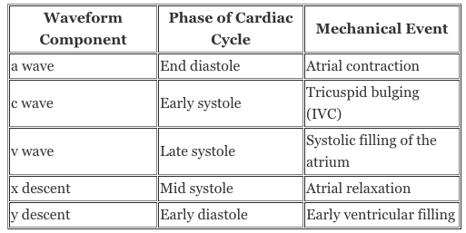
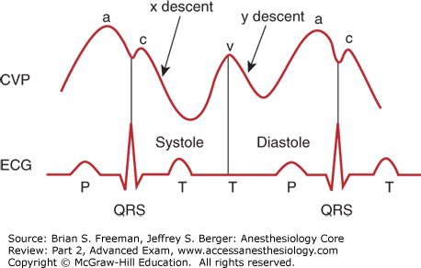
Normal looking waveforms when advancing Swan Ganz catheter
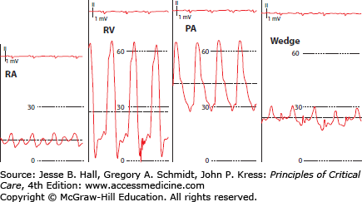

Arterial line square wave test: 